**Bond Valuation and Term Structure of Interest Rates**

**What is a bond?**

A bond is a type of debt security. When you buy a bond, you are lending money to the issuer, in return you will receive:

Periodic interest payments (called coupons) – tiền lãi định kỳ

The principal (face value) at maturity – khi đáo hạn

**I. Valuing Bonds**

**1. Bond Markets & Fixed-Income Securities**

* Fixed-income securities (cổ phiếu thu nhập cố định): Consists of debt instruments with long maturities, periodic interest payments or clear formulas. It is called Fixed Income Securities because investors know the cash flow in advance.
* Examples: Treasury bills and bonds, corporate bills and local government bonds,   
  mortgage-backed securities, and asset-backed securities.
* The main examples of fixed-income securities:
* Treasury bills and bonds
* Corporate bills and bonds
* Local government bills and bonds
* Mortgage-backed securities
* Asset-backed securities
* Fixed income securities may be classified according to some of their characteristics:
* Recallable bonds (trái phiếu có thể thu hồi) - Call option of the issuer (Quyền chọn mua của bên phát hành - trước ngày đáo hạn)



* Redeemable bonds (Trái phiếu có thể mua lại) - Put option of the bondholders (Quyền chọn bán của bên nắm giữ trái phiếu)



* Convertible bonds (Trái phiếu chuyển đổi) - i.e. convertible to stocks (Có thể chuyển đổi thành cổ phiếu)



* Preferred stocks (Cổ phiếu ưu đãi) - Both stock and fixed income features (Lãi cố định như trái phiếu, nhưng là cổ phiếu)

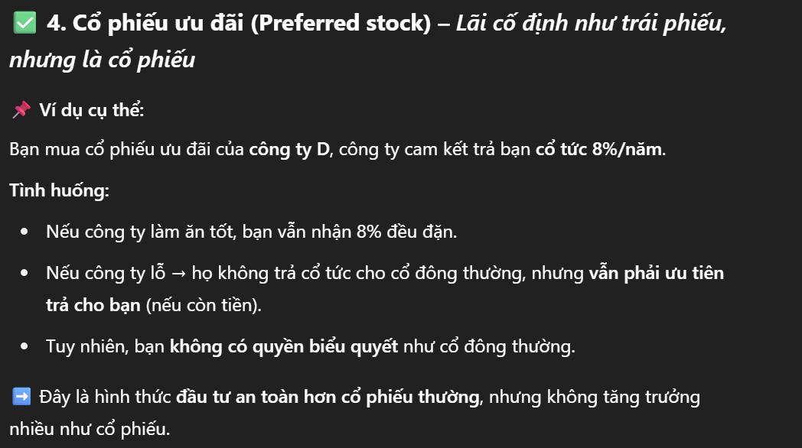

* Indexed bonds (Trái phiếu có chỉ số - Lãi suất thay đổi theo chỉ số như lạm phát) - Oil prices, inflation, GNP, etc. (Giá dầu, lạm phát, GNP, v.v.)

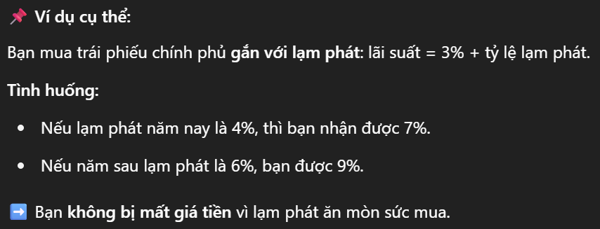

* Impact bonds (Trái phiếu tác động) - Socially responsible investments (ài trợ cho các dự án xã hội)



* Green and blue bonds (Tài trợ dự án môi trường, đại dương) - Focused on sustainability and environmental protection (Tập trung vào tính bền vững và bảo vệ môi trường)



**2. Bills vs. Bonds**

* Bills: Short-term, no coupon, only face value at maturity.
* Bonds: Longer-term, periodic coupon payments, face value at maturity.



🔸 Fixed Coupon: Determined at the time of bond issuance. For example: 5% of the face value is paid each year.

🔸 Floating Coupon: Changes according to a reference rate such as:

* Current market interest rates (e.g. LIBOR, SOFR)
* Inflation rate
* Central bank policy interest rates

**3. Risks (sự khác nhau giữa trái phiếu chính phủ, doanh nghiệp và địa phương)**

* Liquidity Risk: Ease of converting to cash without loss.  
  (**Rủi ro thanh khoản**:Khả năng bán trái phiếu nhanh chóng mà không bị lỗ. Trái phiếu ít người mua sẽ khó bán, dễ bị ép giá)
* Default Risk: Issuer might fail to pay; influences required return.  
  (**Rủi ro vỡ nợ**: Rủi ro tổ chức phát hành không trả lãi hoặc gốc đúng hạn. Rủi ro cao → nhà đầu tư đòi hỏi lãi suất cao hơn)
* is the most important factor affecting bond prices and yields.
* **Government bonds:** generally considered the least risky (the government can print money to pay off debt).
* **Corporate bonds:** higher risk because the company can go bankrupt.
* **Local government bonds:** intermediate risk, depending on the reputation and financial capacity of that locality.

**II. Bond Pricing**

**1. Fundamental Principle**

* The price of any financial instrument is **equal** to the present value of the cash flows expected from the instrument.
* Bond valuation includes 2 basic steps:

Step 1: Estimating cash flows

Step 2: Estimating expected returns → using the discount rate to convert future cash flows to the present.



**2. Formula (Fixed Coupon Bond)**

* A bond with fixed coupon payments may be considered an annuity for which payments are made at the end of each period.

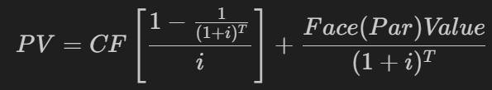

$$P=\sum_{t= 1}^{n}{\frac{c}{{(1+ r)}^{t}}}+\frac{FV}{{(1+ r )}^{n}}$$

Where:

* P: Bond price at t = 0
* C: Fixed coupon payments to be made at the end of each period from t=1 to t=n
* r: Market interest rate, which may also be interpreted as the required rate
* FV: Face value
* n: Number of periods remaining

**3. Payment Frequency**

* More frequent payments → higher price.
  + Annually, semi-annually, quarterly.

**III. Time to Maturity & Bond Price Dynamics**

* Price converges to face value as maturity approaches.  
  (Càng gần đến ngày đáo hạn, **giá trái phiếu càng tiến gần về mệnh giá (Face Value))**
* Price path differs based on coupon vs. market rate relationship.

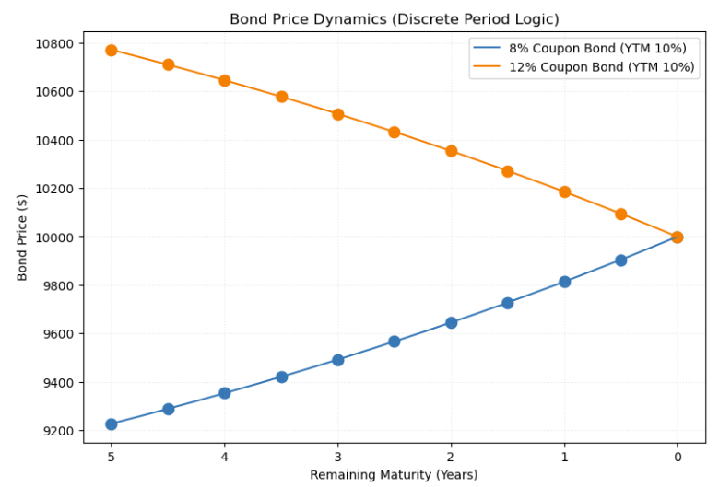

**IV. Yield Measures**

**1. Current Yield**

|  |
| --- |
| **Current Yield = $\frac{Annual Coupon}{Market price}$** |

* Advantages:
* Very simple to calculate.
* Tells how much profit the investor will earn per year from the current price.
* Shortcoming (nhược điểm):
  + Ignores time value of money (Tất cả dòng tiền được xem là ngang nhau, không chiết khấu)
  + Ignores capital gains or losses (Nếu bạn mua trái phiếu với giá thấp và giữ đến đáo hạn → có lời → không tính đến trong công thức)
  + Does not reflect actual total yield (Chỉ nhìn vào tiền lãi coupon, bỏ qua hoàn toàn mệnh giá hoàn lại)
* Current Yield: Simple, fast, but not accurate for comprehensive evaluation of bond investment performance.
* To be more precise, investors should use Yield to Maturity (YTM)

**2. Yield to Maturity (YTM)**

* **The return if the bond is held to maturity**, including:
  + All coupon payments
  + Any gain or loss from buying at a price different from face value
* YTM is like the **internal rate of return (IRR)** of the bond
* Includes full return (coupon + capital gain/loss), respects time value.

=> More accurate than current yield because it includes time value and capital changes

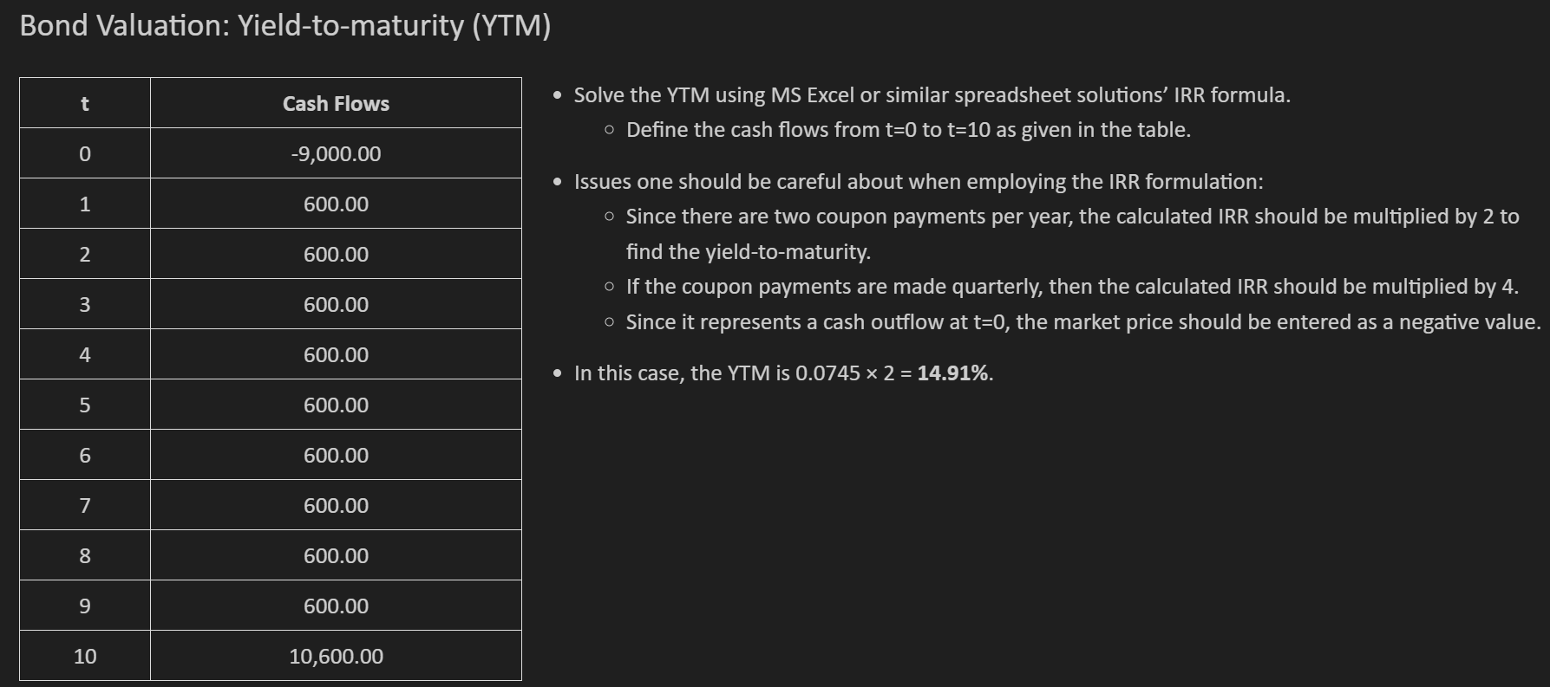

**3. Reinvestment Risk**

* YTM assumes that **coupon payments are reinvested** at the same YTM rate.
* If reinvestment rates change → **actual return differs from YTM**  
  This is called **reinvestment risk** and is important when interest rates are volatile.



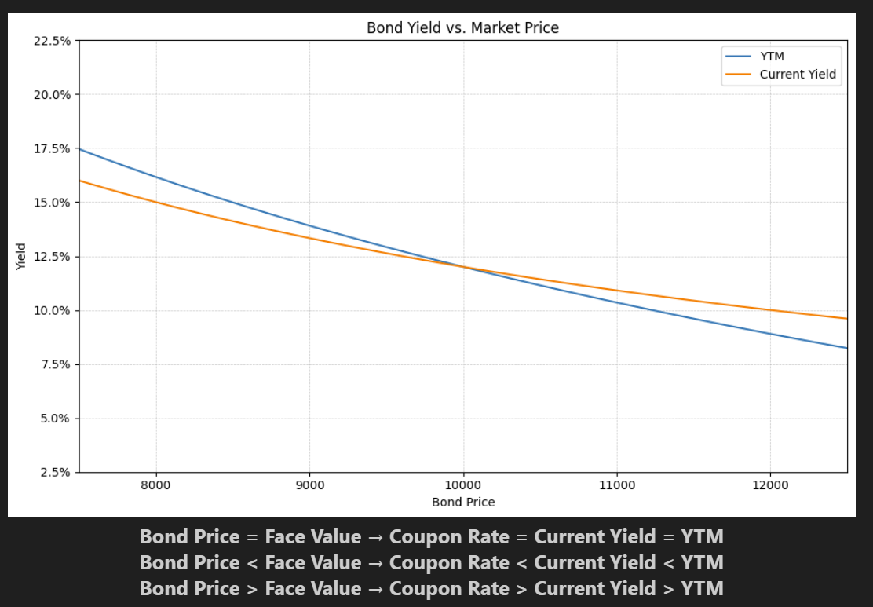

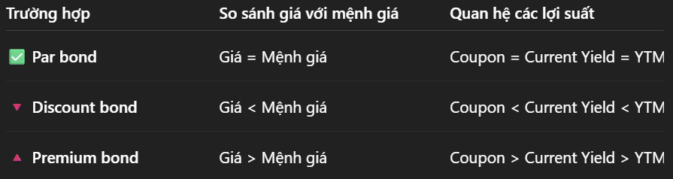

* YTM always adjusts for both coupon and principal repayment, so it is more sensitive than Current Yield.
* When price increases (premium) → yield decreases
* When price decreases (discount) → yield increases
* Higher bond price → Lower Yield

YTM is always a more accurate measure than Current Yield

Comparing Yield levels helps identify bonds that are premium, discounted or at par

**V. Term Structure of Interest Rates (Cấu trúc kỳ hạn của lãi suất) (TSIR) – Yield Curve**

**1. Definition**

* It is the relationship between the yields (YTM) of securities of the same type but different maturities.
* **The yield curve** is a graph that shows this relationship (x-axis: maturity, y-axis: yield): Shows market expectations of future interest rates
* Built from zero-coupon bond yields (spot rates).
* Spot Rates: Implied yield on zero-coupon bond.
* Forward Rates (lãi suất kỳ hạn): Expected future interest rates derived from spot rates.

**2. Meaning**

* An important tool in bond pricing and bond market evaluation.
* Allows comparison of investors' future interest rate expectations with market expectations.
* Provides spot rates to discount future cash flows.

**3. Technical analysis**

* Do not take directly from the actual interest rate, but assume zero-coupon bonds to infer the theoretical yield.
* From there, we can use spot rates to calculate the present value of future cash flows.

**VI. Default Risk**

* Bonds with default risk trade at lower prices → higher YTM   
  (YTM được tính dựa trên **dòng tiền cam kết** (promised cash flows), không phải dòng tiền thực tế. Do giá trái phiếu thấp hơn, YTM sẽ cao hơn.)  
  (Trái phiếu có rủi ro tín dụng cao hơn sẽ có YTM cao hơn để đền bù cho nhà đầu tư.)

|  |
| --- |
| **YTM = Risk – Free Rate + Credit Spread** |

* Expected return may remain same even with higher YTM.

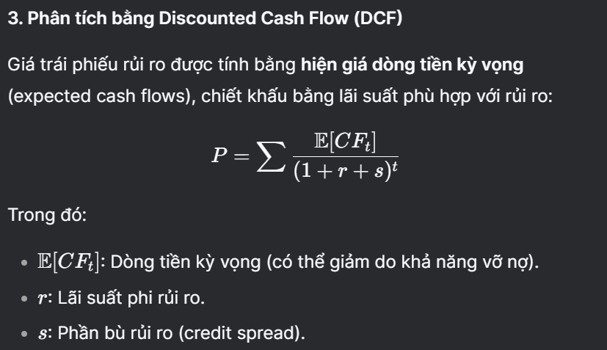

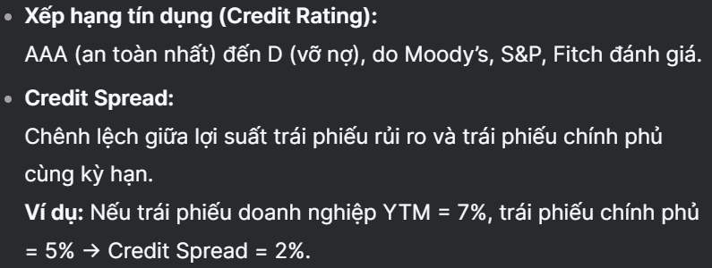

* Scenarios:
  + **Full default** (only 90% repaid) → higher YTM, same expected return.
  + **Partial default probability** → **Price = expected value / (1+r)**,   
    again YTM > expected return.

**VII. Exercises**

**Exercise 5.1: Interest Rate Risk**

* Compare price sensitivity of short vs. long-term bonds (same coupon).
* Conclusion: Longer maturity → higher sensitivity to interest rate changes.

**Exercise 5.2: Arbitrage**

* Spot rates implied from zero-coupon prices.
* Use to compute "fair price" of a coupon bond.
* Arbitrage if actual price ≠ computed price.

**Exercise 5.3: Credit Rating Impact**

* Horizon Corp bond pricing under Aa and Baa scenarios.
* Lower rating → higher required return → lower bond price.